Collection types

- Array, list, queues

- Strings

- Dictionaries sincronaze name / value (instead using index)

- Tables

**Dictionaries**

- Instead of searching by index it is use a string value to get the reference value

- Used to pull data from Orquestra queues

- When returning a list of values in one single parameter

- When passing multiple values in one single parameter

Arrays (fix size), List not fixed size

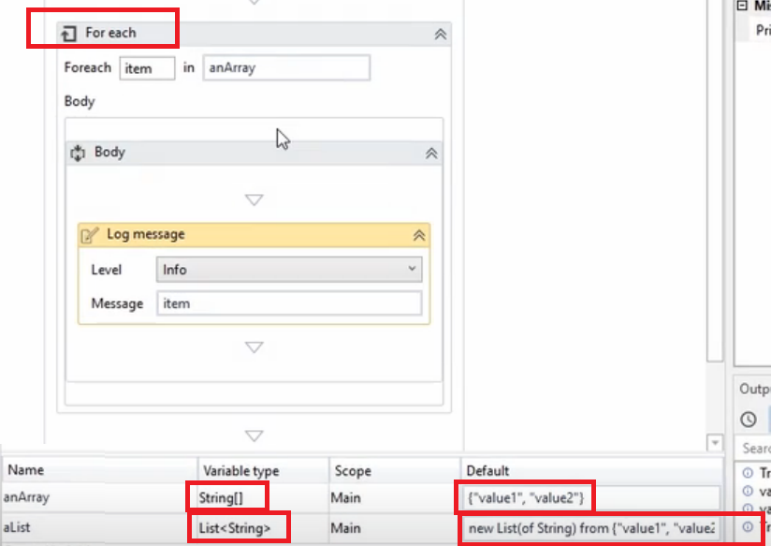

|  |  |
| --- | --- |
| To add a new value to a list, we use invoke Programming \ Execute \ Invoke  The value is set in Parameters |  |

**Dictionary**

Define variable and set Browse for types



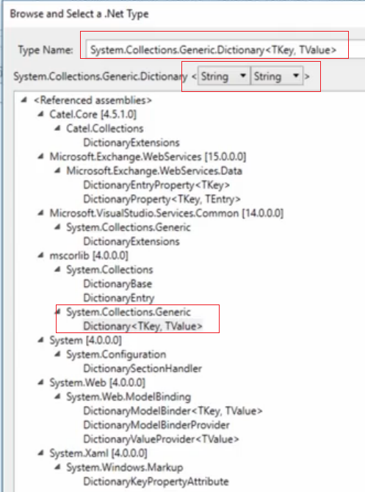



Assign or set a new value to a dictionary

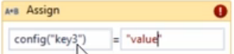

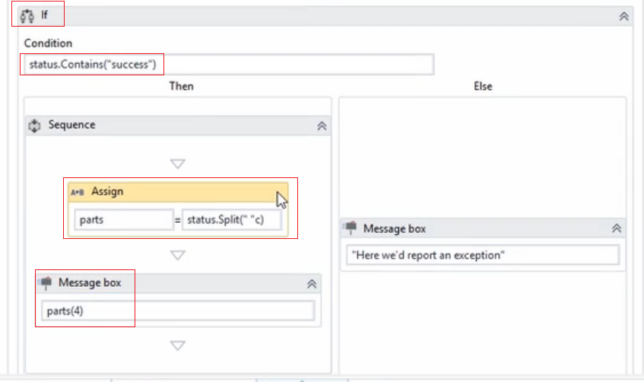

status.Split({"Record","has"}, StringSplitOptions.None);

Operation ended succesfully. Record 1234 has been created

part(1) is going to have 1234

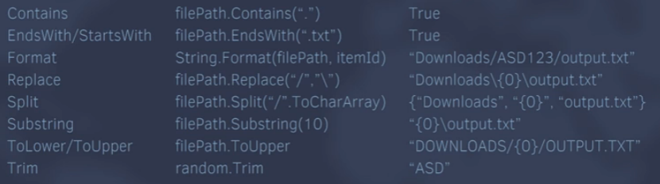

Now.ToString(“MMMM/YYYYY”)